May 24, 2023

Dear St. Thomas Aquinas Families,

Welcome, welcome to the end (or continuation) of another school year and the all-too soon beginning of another. I pray that this letter finds you joyful as we come to the end of
our Easter season in the next few days. I know joy is something that sounds like a foreign
concept as we continue to see the sufferings and difficulties of this world. But we are an
Easter people, ever rejoicing in Our Almighty Father, Son, and Holy Spirit. Ever adoring
and trusting in the Holy Trinity’s care and love of all of us!
This winter and spring has been a continued challenge as our world expresses more loudly everyday their rejection of Our God. So much to challenge our resolve, but this is where our faithfulness and fidelity to God comes in. The preverbal “where the rubber meets the road” in our faithfulness to all that we hold to be our abiding truths in Our Lord; trust, charity, mercy, patience, wisdom… We continue to place ourselves in the loving arms of Our Heavenly Father and surrender in peace to what comes next or at least that is the hope for each new day in a Catholic life. Well, summer will soon be upon us and let us seek peace in the beautiful blooming world around us. The grass is so green and playful song of the birds are so welcome. Every early morning, I hear the American Robin singing his praises to God for another new day, and I am quickly reminded to do the same.
Well, onto our business. On the STAA website you will find the enrollment forms for
2023-24 which can be printed for each family that is enrolling, and attendance forms
that can be used for the all the children being schooled if they share the same days of
study. Please submit your enrollment forms for the coming school year by September
1st, 2023 or contact me if you would like an extension. All attendance forms for this
2023-24 school year are due on June 30th, 2023. If you school year-round, please
use the June 30th date as way to mark the end of one school year and the begin of the
next.
Your enrollment papers may be mailed to me or scanned and emailed, and you have the
option to pay your enrollment fee of $40 per school year per family by making
payments online or you may pay the enrollment fee by check. Please make all checks
payable to Helen Swavely, STAA.

Once payment online is made, you can mail your enrollment papers to the address listed on the letterhead of this letter. Oh, and please if ever the enrollment fee of $40 is ever a hardship for your family, please contact me as there are scholarships that can be applied.

Thank you all again for being part of the STAA family and know you are in our family’s
daily prayers. May you all have a blessed and restful summer! Please never hesitate to
contact me to assist you in navigating the state homeschooling laws and curriculum questions or concerns. God Bless You and your families with a happy school year to come!

Yours In Christ,
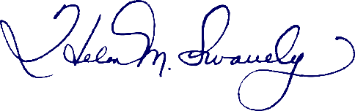
Director, STAA

